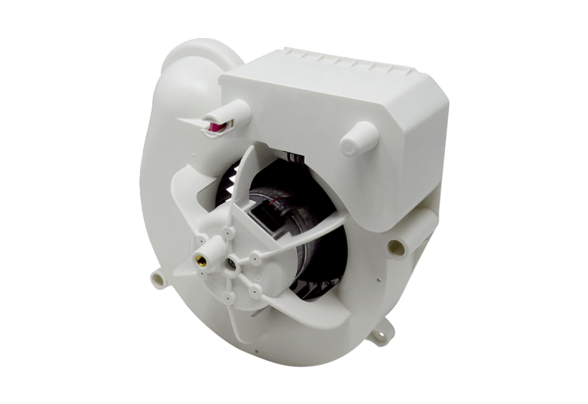Fan insert VE ER-AP 60 HRange: B
Article number: E084.0154.0000Manufacturer: MAICO

