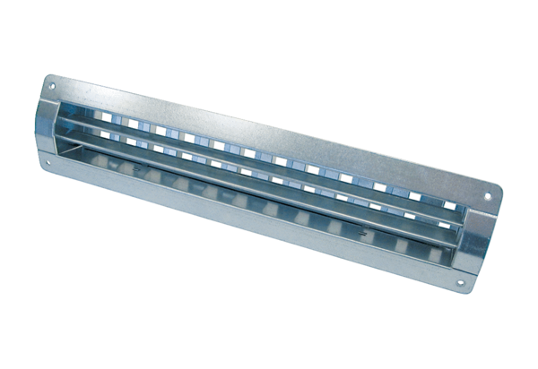Internal grille LGR 52/12Packing unit: 1 pieceRange: C
Article number: 0151.0361Manufacturer: MAICO

