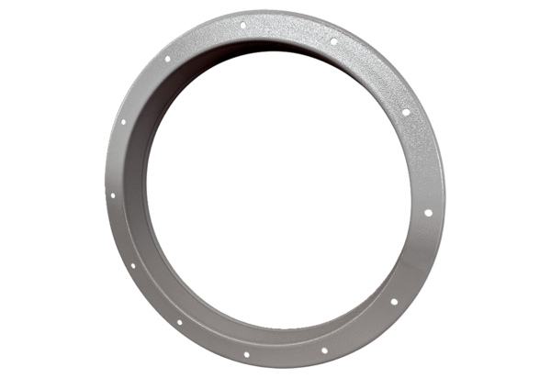Counter socket GSI 100Packing unit: 1 pieceRange: C
Article number: 0073.0270Manufacturer: MAICO

