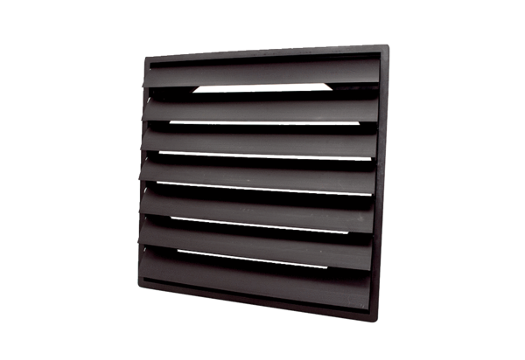Shutter AS 71 ExPacking unit: 1 pieceRange: C
Article number: 0151.0410Manufacturer: MAICO

