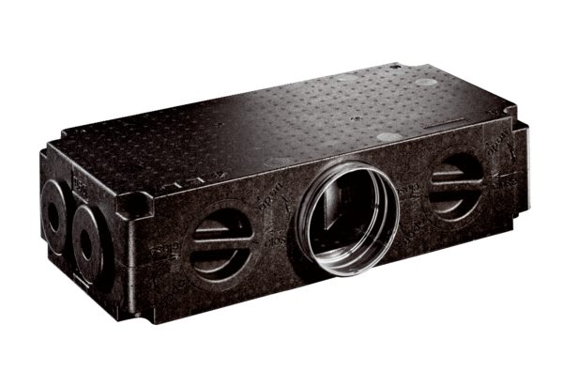Air distributor made of plastic, 8-way MF-V90-8Packing unit: 1 pieceRange: K
Article number: 0059.0979Manufacturer: MAICO

