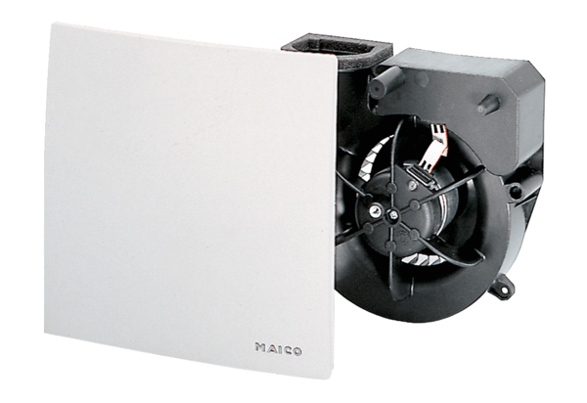Fan insert ER 60 GVZPacking unit: 1 pieceRange: B
Article number: 0084.0107Manufacturer: MAICO

