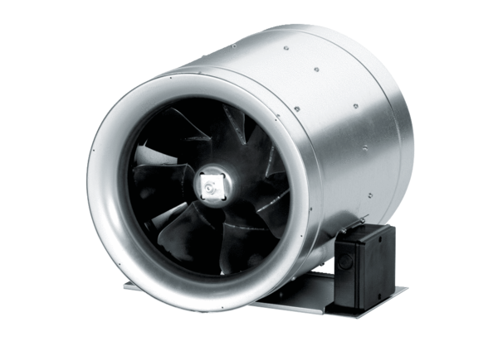Diagonal fan EDR 31Packing unit: 1 pieceRange: C
Article number: 0080.0657Manufacturer: MAICO

