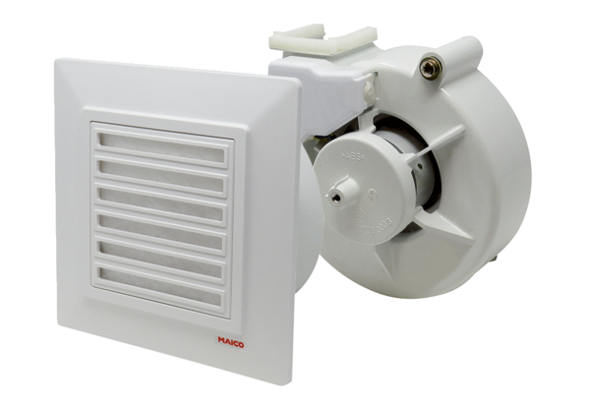Fan insert with cover VEA ER 17/60-1 VZRange: B
Article number: E080.0781.0000Manufacturer: MAICO

