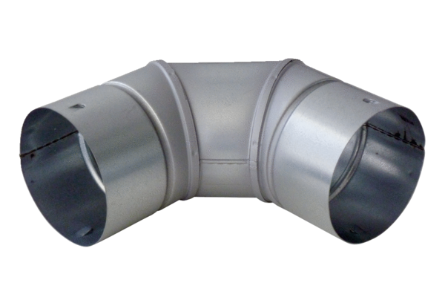90° sheet metal elbow MF-B75Packing unit: 1 pieceRange: K
Article number: 0018.0067Manufacturer: MAICO

