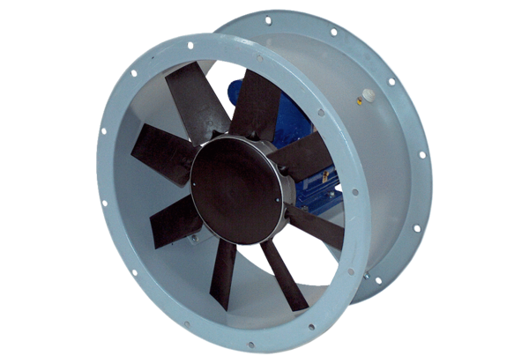Axial duct fan DAR 90/4 9,2Packing unit: 1 pieceRange: C
Article number: 0073.0156Manufacturer: MAICO

