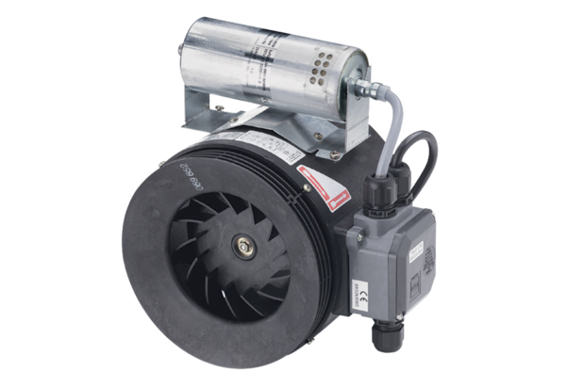Semi-centrifugal duct fan ERM 18 Ex e/60 HzPacking unit: 1 pieceRange: C
Article number: 0080.0373Manufacturer: MAICO

