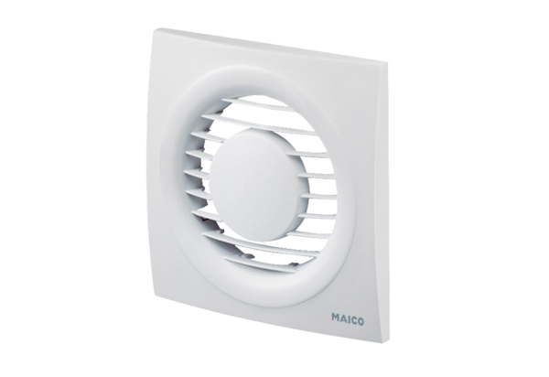Cover ABD ECA piano 2Range: A
Article number: E059.1125.9100Manufacturer: MAICO

