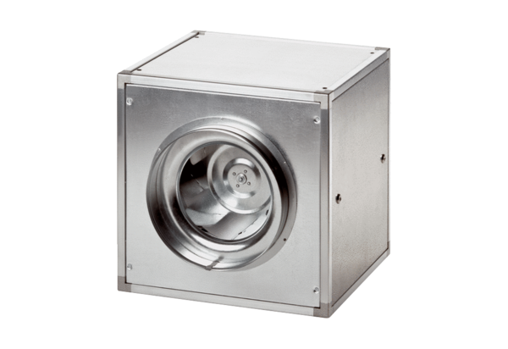Quickbox DSQ 50/6Packing unit: 1 pieceRange: C
Article number: 0080.0039Manufacturer: MAICO

