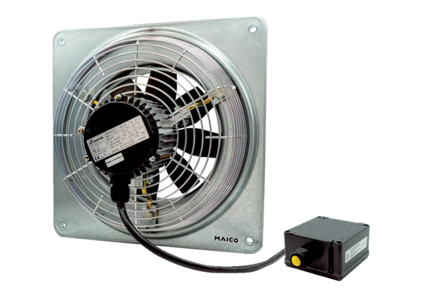Axial wall fan DZQ 50/4 B Ex ePacking unit: 1 pieceRange: C
Article number: 0083.0185Manufacturer: MAICO

