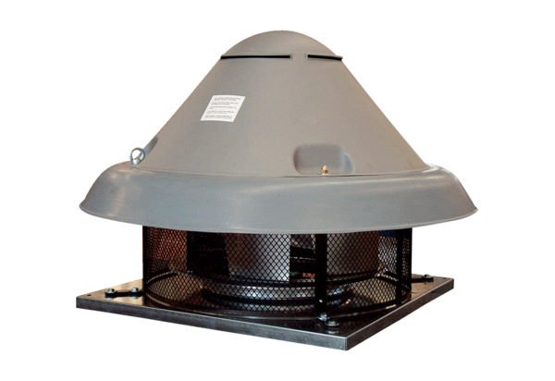Centrifugal roof fan DRD H 50/4Packing unit: 1 pieceRange: C
Article number: 0073.0056Manufacturer: MAICO

