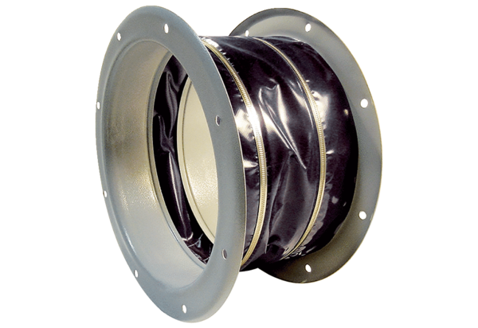Flexible coupling ELI 80 ExPacking unit: 1 pieceRange: C
Article number: 0073.0580Manufacturer: MAICO

