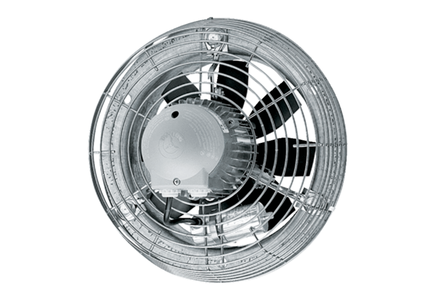Axial wall fan DZS 40/42 BPacking unit: 1 pieceRange: C
Article number: 0094.0066Manufacturer: MAICO

