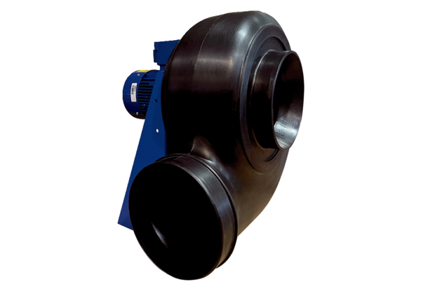Centrifugal blower GRK R 50/4 D ExPacking unit: 1 pieceRange: C
Article number: 0073.0456Manufacturer: MAICO

