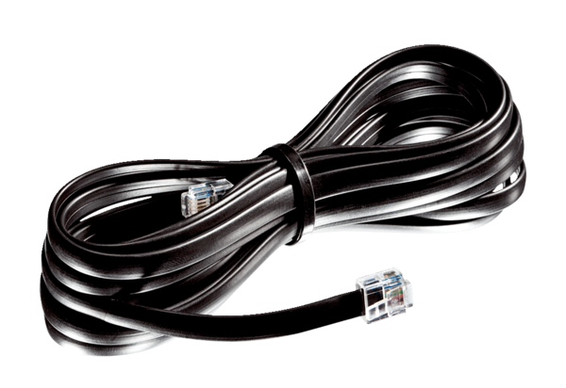Connecting duct WRG 35-TAK 10Packing unit: 1 pieceRange: K
Article number: 0092.0503Manufacturer: MAICO

