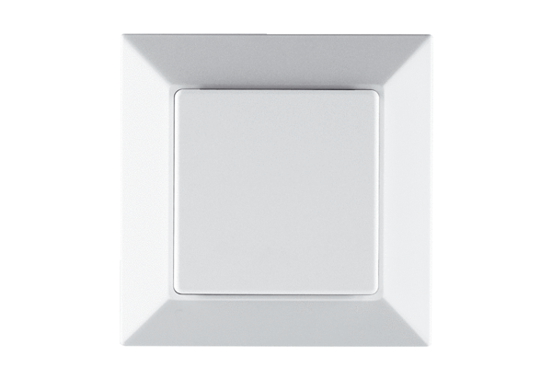Humidity sensor PP 45 HYPacking unit: 1 pieceRange: K
Article number: 0157.0365Manufacturer: MAICO

