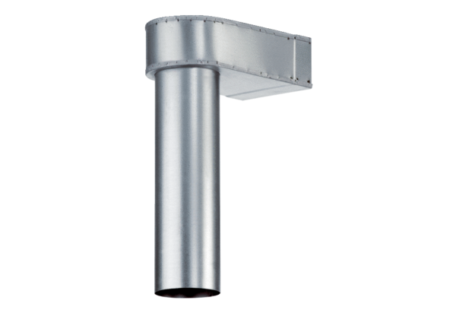Bracket MF-WL125 80/150Packing unit: 1 pieceRange: K
Article number: 0018.0499Manufacturer: MAICO

