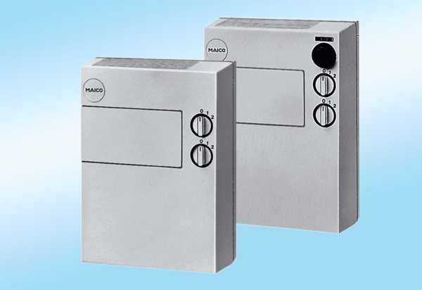Fresh air unit FLG 100 ZPacking unit: 1 pieceRange:
Article number: 0082.0053Manufacturer: MAICO

