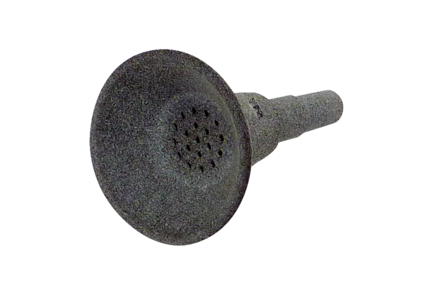Insect protection funnel IST MDRPacking unit: 1 pieceRange: E
Article number: E059.2087.0000Manufacturer: MAICO

