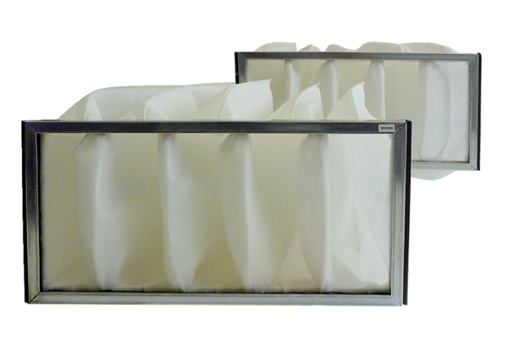Air filter, replacement KF 28Packing unit: 2 piecesRange: D
Article number: 0093.0683Manufacturer: MAICO

