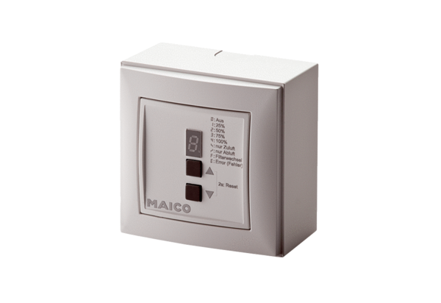Room air control RLS 4 APPacking unit: 1 pieceRange: K
Article number: 0157.0843Manufacturer: MAICO

