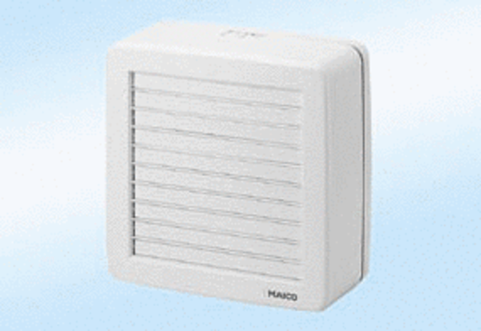Window fan EV 22Packing unit: 1 pieceRange: C
Article number: 0080.0810Manufacturer: MAICO

