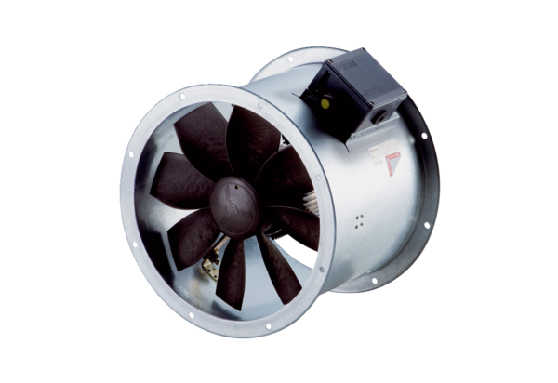Axial duct fan DZR 35/6 B Ex tPacking unit: 1 pieceRange: C
Article number: 0086.0726Manufacturer: MAICO

