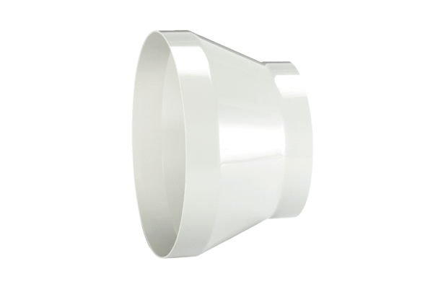Reducer REM 28/25Packing unit: 1 pieceRange: C
Article number: 0059.0638Manufacturer: MAICO

