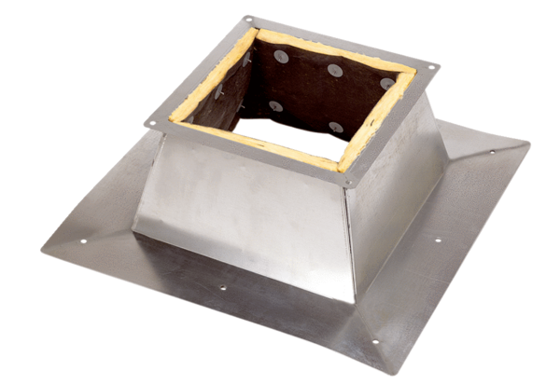Roof socket for flat roofs SO 45Packing unit: 1 pieceRange: C
Article number: 0093.0874Manufacturer: MAICO

