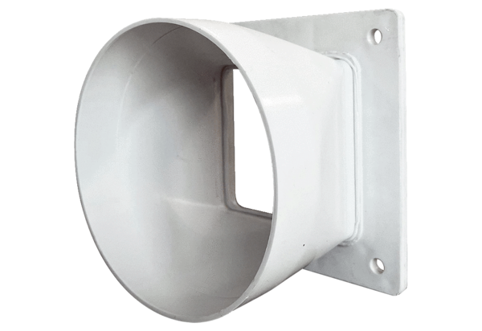Transition adapter URRI GR 25Packing unit: 1 pieceRange: C
Article number: 0073.0313Manufacturer: MAICO

