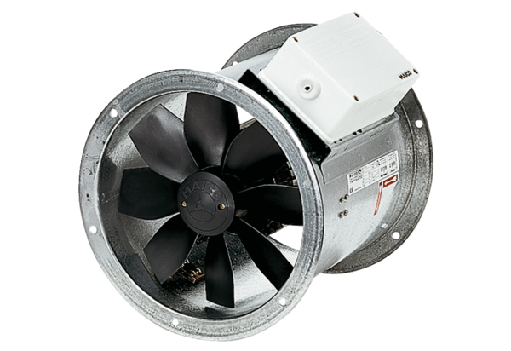Axial duct fan DZR 25/42 BPacking unit: 1 pieceRange: C
Article number: 0086.0041Manufacturer: MAICO

