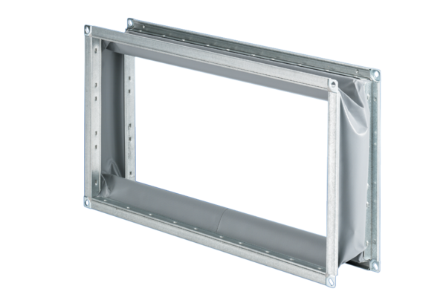Flexible coupling ELP 56Packing unit: 1 pieceRange: D
Article number: 0092.0124Manufacturer: MAICO

