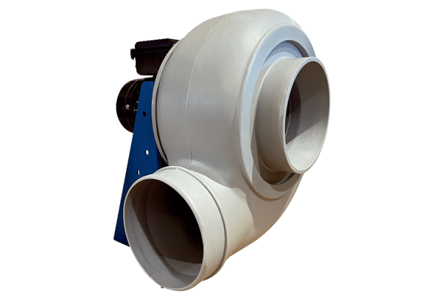Centrifugal blower GRK R 35/6 DPacking unit: 1 pieceRange: C
Article number: 0073.0523Manufacturer: MAICO

