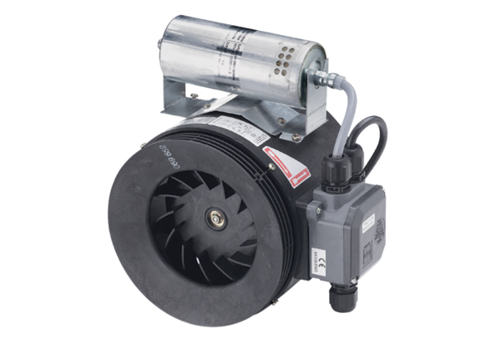Semi-centrifugal duct fan ERM 25 Ex t/60 HzPacking unit: 1 pieceRange: C
Article number: 0080.0378Manufacturer: MAICO

