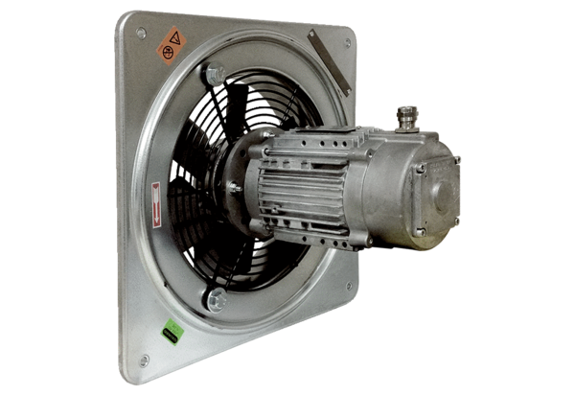Axial wall fan DAQ 63/4 ExPacking unit: 1 pieceRange: C
Article number: 0073.0334Manufacturer: MAICO

