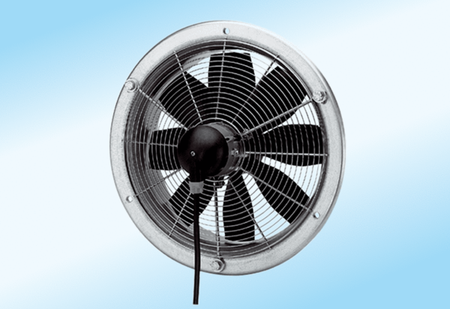Axial wall fan DZS 20/2 A-ExPacking unit: 1 pieceRange: C
Article number: 0094.0102Manufacturer: MAICO

