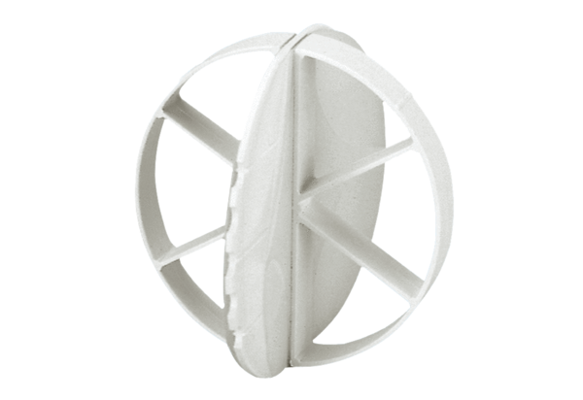Storm protection ALDS 10Packing unit: 1 pieceRange: B
Article number: 0152.0056Manufacturer: MAICO

