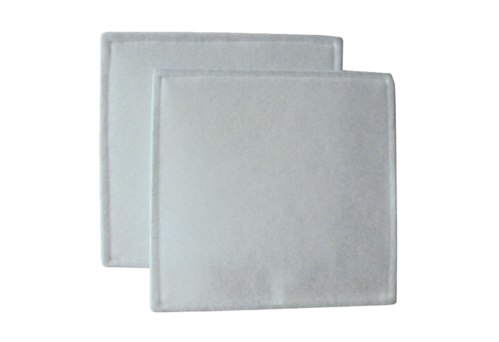Air filter, replacement RF 35Packing unit: 2 piecesRange: C
Article number: 0093.0691Manufacturer: MAICO

