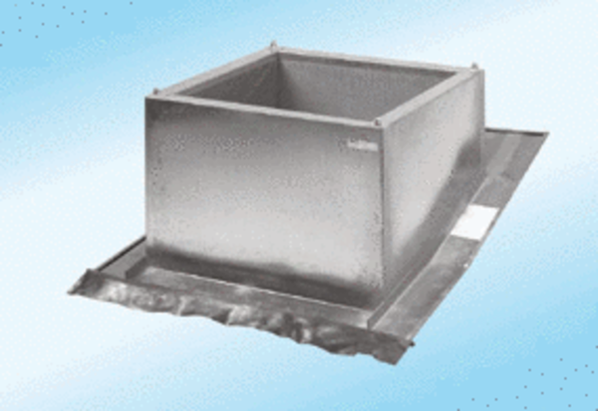Roof socket for pitched roofs SDS 63Packing unit: 1 pieceRange:
Article number: 0093.0955ALTManufacturer: MAICO

