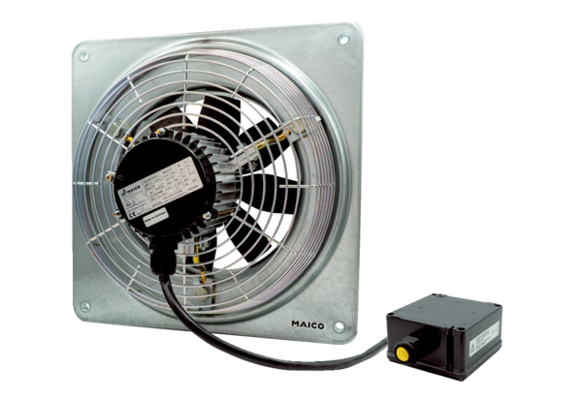Axial wall fan DZQ 20/4 B Ex ePacking unit: 1 pieceRange: C
Article number: 0083.0170Manufacturer: MAICO

