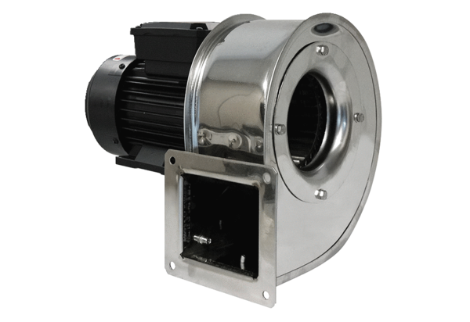Centrifugal blower GRM ES 14/2 EPacking unit: 1 pieceRange: C
Article number: 0073.0318Manufacturer: MAICO

