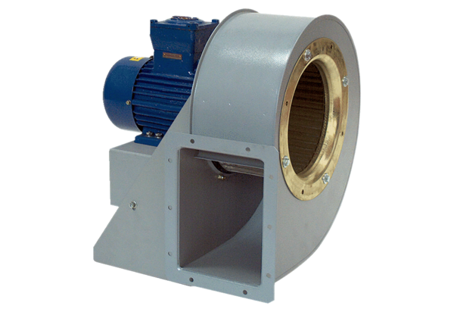Centrifugal blower GRM HD 20/4 ExPacking unit: 1 pieceRange: C
Article number: 0073.0397Manufacturer: MAICO

