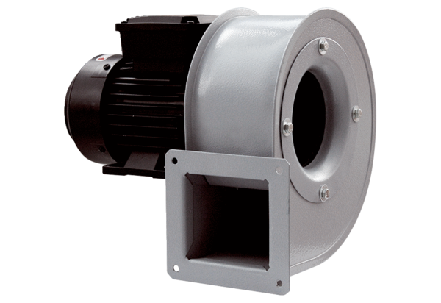Centrifugal blower GRM HT 10/2Packing unit: 1 pieceRange: C
Article number: 0073.0279Manufacturer: MAICO

