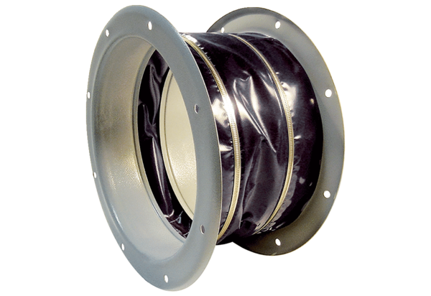Flexible coupling ELI 100 ExPacking unit: 1 pieceRange: C
Article number: 0073.0582Manufacturer: MAICO

