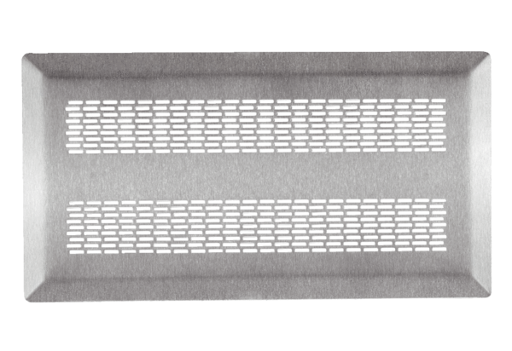Floor grille FFS-FGEPacking unit: 1 pieceRange: K
Article number: 0055.0902Manufacturer: MAICO

