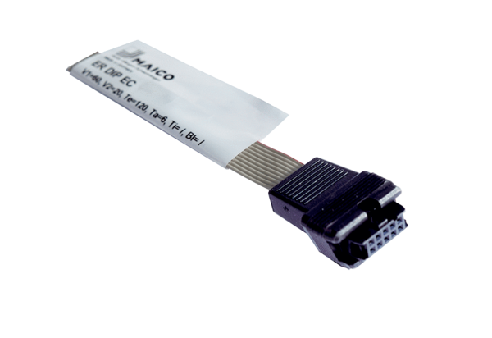Dongle ER DIP ECPacking unit: depending on the order, from 15 itemsRange: B
Article number: 0157.1648Manufacturer: MAICO

