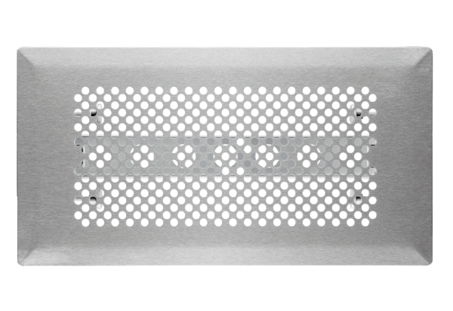Floor grille FFS-FGRPacking unit: 1 pieceRange: K
Article number: 0055.0888Manufacturer: MAICO

