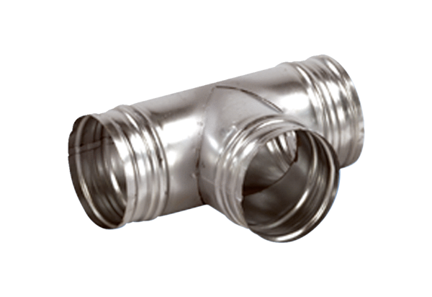90° branch AB 180-150<data>
<p class="FT">Packing unit:</p>
</data>
1 piece<data>
<p class="FT">Range:</p>
</data>
K
<data>
<p class="FT">Article number:</p>
</data>
0055.0377<data>
<p class="FT">Manufacturer:</p>
</data>
MAICO

