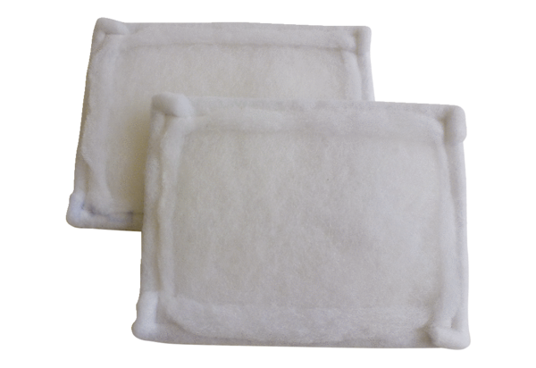Air filter, replacement FE 15-1Packing unit: 2 piecesRange: C
Article number: 0093.1223Manufacturer: MAICO

