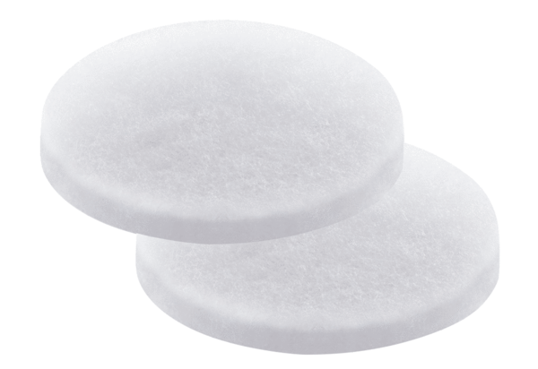Air filter, replacement PP 45 G2Packing unit: 2 piecesRange: K
Article number: 0093.0273Manufacturer: MAICO

